HOW TO GET VACCINATED IN HUNGARY?
A STEP-BY-STEP GUIDE FOR INTERNATIONAL STUDENT ON HOW GET A VACCINE AGAINS COVID-19

„What documents do I need to get vaccinated in Hungary?”
Note: You can only get vaccinated in Hungary if you have a residence permit, or a registration card for EEA citizens.
„I have a residence permit like this.”
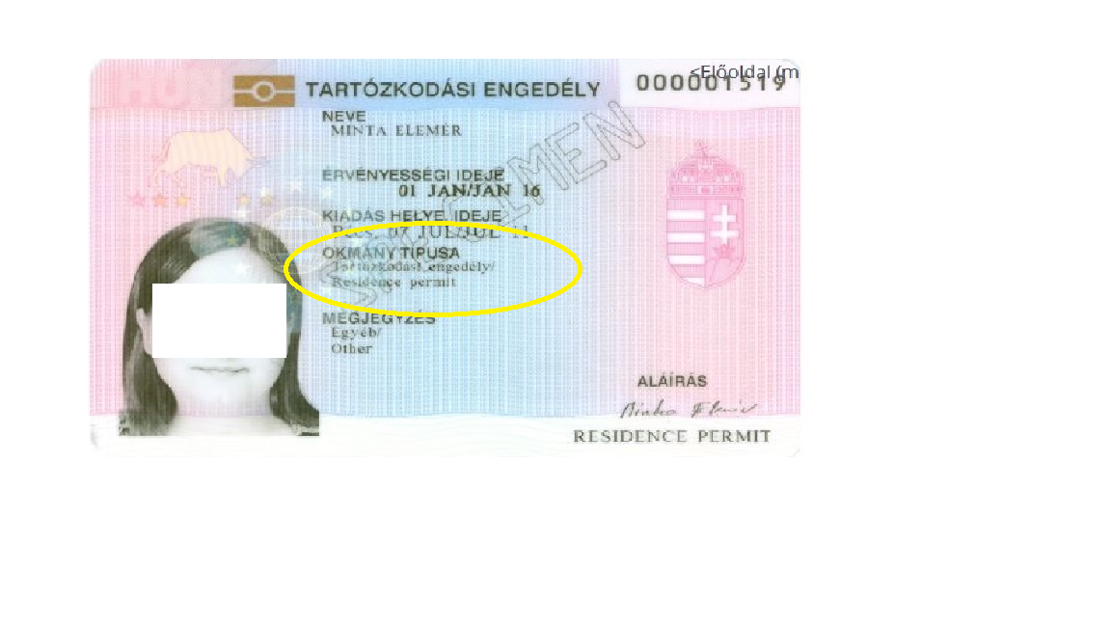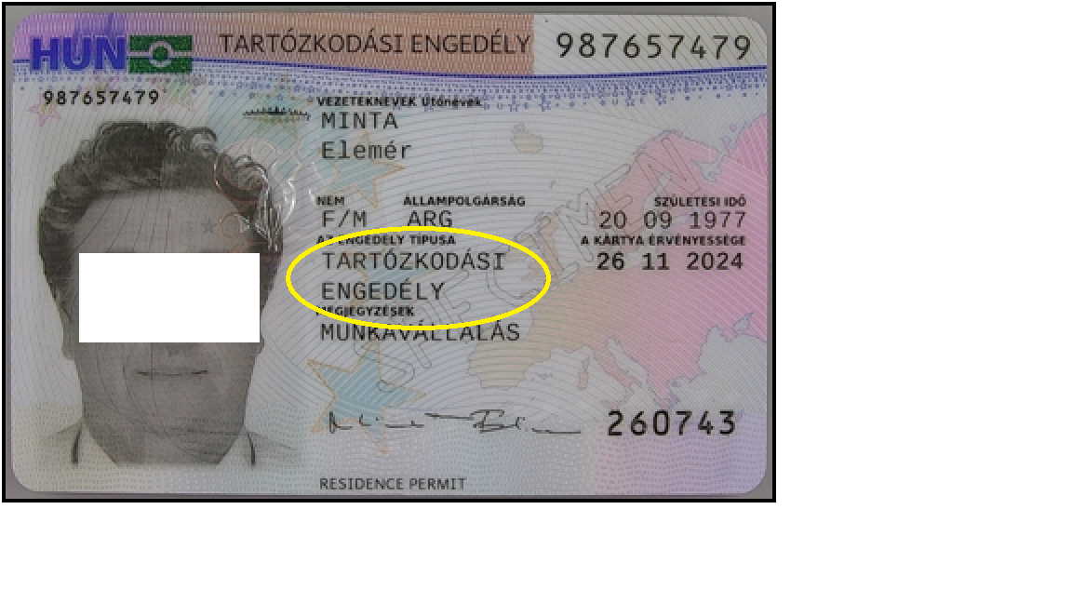
Residence permit = tartózkodási engedély
Please follow the guide below.
„I have a registration card for EEA citizens.”
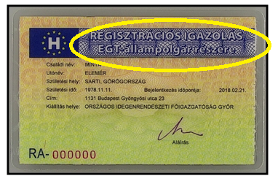
Please follow the guide below.
“I have a temporary residence permit.”
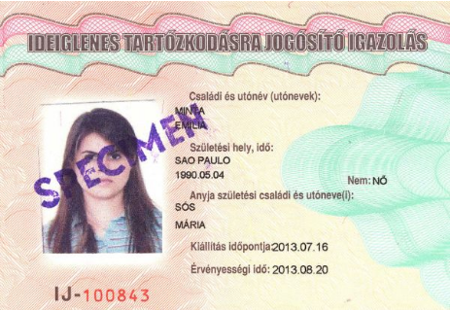
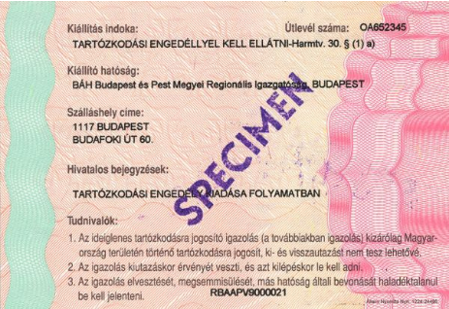

Note! You cannot get vaccinated with this permit in Hungary because it is only a temporary permit until you get your normal residence permit.
Please wait until your residence permit is ready then register for the vaccine as outlined in the guide below.
REGISTERING FOR THE VACCINE
“I have a residence permit/registration card. How can I register for the vaccine?”
1) Go the https://vakcinainfo.gov.hu/ website.
2) Click on “register” on the right side of the main page.
3) Fill in the form and click on the “register” button.

Note! If you do not have a „TAJ” number (Hungarian social security number), then you will have to register with your residence permit number or your personal identity number.

“I have a residence permit number.”

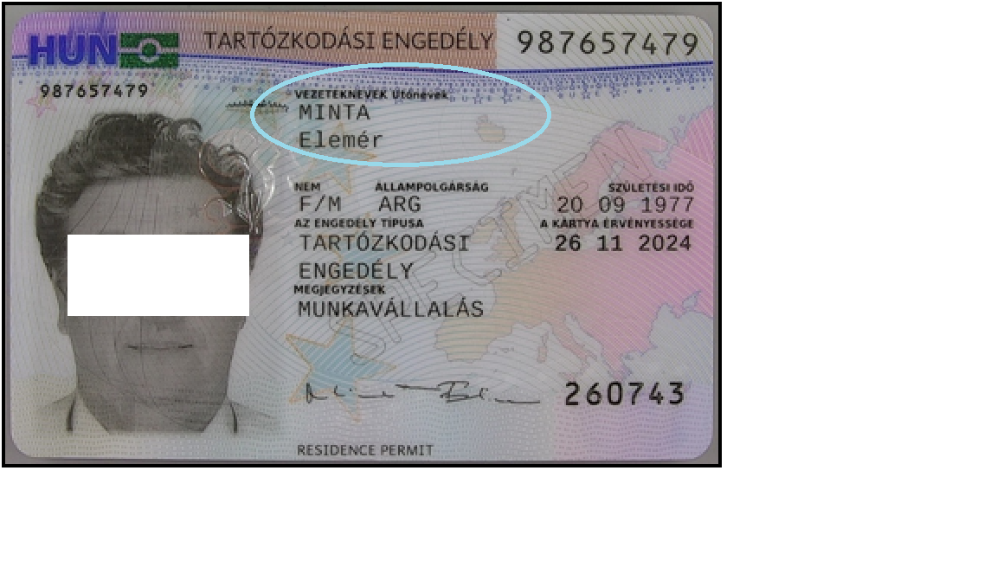
Make sure that you type your name in the exact same format and order as it is on your card. Otherwise the system may not find you in the database.

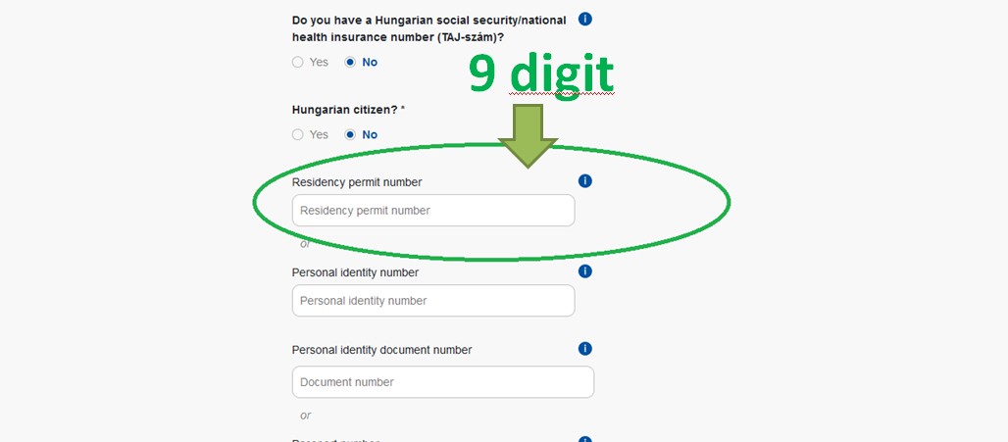
9 digits on the top right side. Make sure that it matches exactly with your card.

“I have a registration card for EEA citizens.”
You will need to write in your personal identification number.
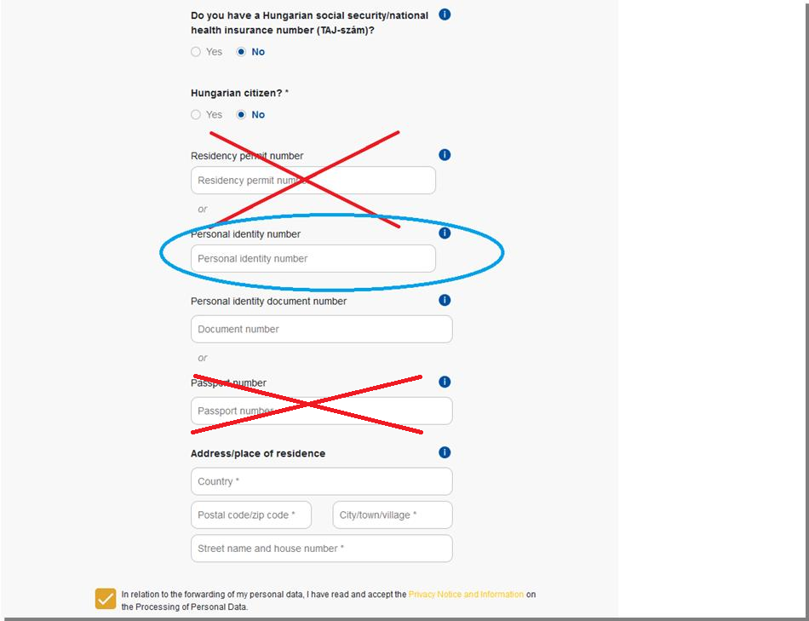
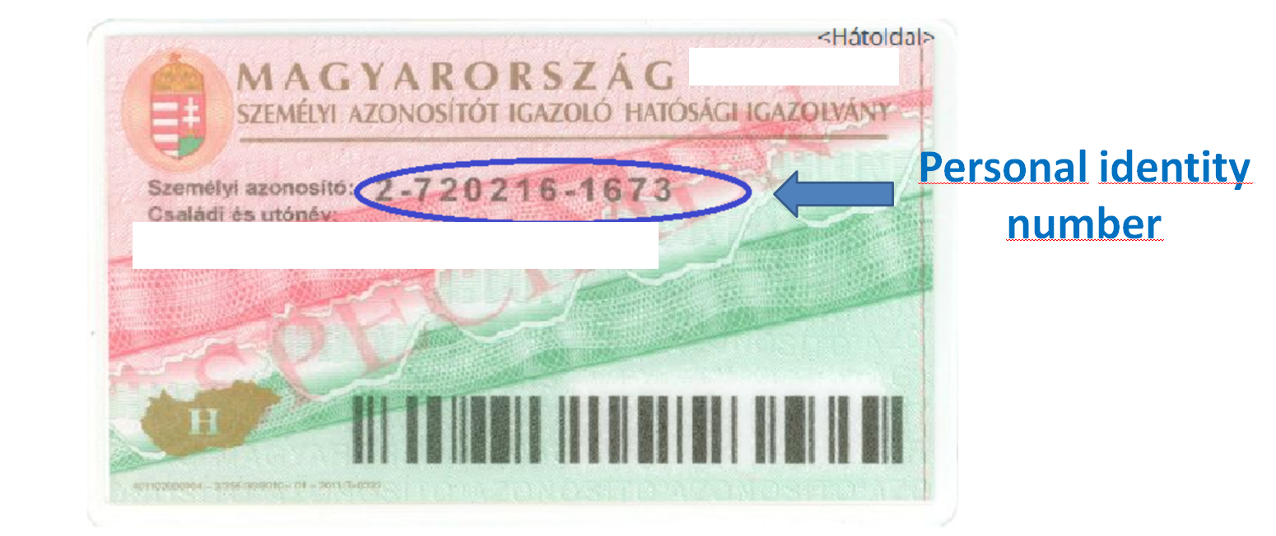
Personal identity number = Személyazonosító szám

Note! You will receive an e-mail about your successful registration in both cases.

„I have registered for the vaccine, what’s next?”
You will need to book an appointment to get your vaccine shot.
“How do I do that?”
1) If you do not have a TAJ number, go to: https://www.eeszt.gov.hu/hu/covid-vaccination-booking
If you have a TAJ number, go to: https://www.eeszt.gov.hu/hu/web/guest/covid-oltas-idopontfoglalas Note! This site is in Hungarian only.
2) Fill in the form and click on the “submit” button.
Note! Please use the same ID type and number you used for registration.
The “PID number” should be in the e-mail you received after registration.
3) When booking an appointment, you can choose:
- appointment date
- appointment place
- type of vaccine (depending on availability)
Note! Please make sure to get to your appointment on time and bring your ID which you used for registration with you.

GETTING AN IMMUNITY CERTIFICATE (“COVID PASS”)
There are three types of Covid Passes accepted in Hungary:
- The Hungarian Covid Pass
- EU Digital Covid Certificate (DCC)
- National Covid Passes accepted based on bilateral agreements
THE HUNGARIAN COVID PASS
You can get a Hungarian Covid Pass if you got your vaccine in Hungary or in one of the following countries:
- Any EU country
- EU Candidates: Albania, North Macedonia, Montenegro, Serbia, Turkey
- OECD: Australia, Canada, Chile, Colombia, Israel, Japan, Mexico, New Zealand, Norway, South Korea, Switzerland, United Kingdom, United States of America
- Turkic Council: Azerbaijan, Kazakhstan, Kyrgyzstan, Uzbekistan
- Other: Russia, China, United Arab Emirates, Bahrein, and other countries listed in government decrees.
Note! If you already have a Covid Pass from your country of origin, please check the list of accepted foreign Covid Passes on the government website (https://kormany.hu/kulgazdasagi-es-kulugyminiszterium/vedettsegi-igazolasok).

“I got vaccinated in Hungary, how do I get a Covid Pass?”
If you got your vaccine in Hungary after registration, then your Covid Pass will be sent to you automatically to your registered address.
“I got my vaccination in my home country/elsewhere.”
If you have a residence permit and you were vaccinated in any country listed above, then you can request a Hungarian Covid Pass personally in any Government Office.
Note! Foreign citizens are not eligible to use the Hungarian Covid Pass App.
“What documents do I need to bring with me to the Governemnt Office?”
You are required to show a certificate about your vaccination in Hungarian and/or English.
Note! Your certificate must contain: the type of the vaccine, the time and place of vaccination, a signature and stamp from the doctor/health service provider/authority vaccinating you.
Please also bring your ID, passport, residence permit, registration card, address card with you.
“When will I get my Covid Pass?”
Vaccinated in Hungary: Covid Pass sent within 8 days (there may be delays due to the great number of requests)
Vaccinated elsewhere: Covid Pass sent within 15 days (there may be delays due to the great number of requests)
“Where do they send me my covid pass?”
They send it to your registered address or to the (Hungarian) postal address you write in your request in case of being vaccinated elsewhere.
“How long will my Covid Pass be valid?”
The Hungarian vaccination Covid Pass does not expire according to the current regulation.

EU DCC
Hungary also accepts and issues EU DCC from 1 July 2021.
Note! Accepted vaccine types may differ in EU countries, so having an EU DCC issued in Hungary may not be accepted in all EU countries. Please always refer to the consular services of your country of destination. EU-approved vaccines must be accepted in every EU country.
“Can I get an EU DCC?”
You can get an EU DCC, if:
- You registered and received your vaccination in Hungary
- If you received your vaccination in any country listed above
- If you have a Covid Pass from another country which is accepted in Hungary based on a bilateral agreement
- If you were vaccinated anywhere with any vaccine type recognized in Hungary
“How to get my EU DCC?”
You can request your EU DCC personally at any Government Office.
“What documents do I need to bring with me to the Government Office?”
- If you received your vaccination in Hungary:
Please also bring your ID, passport, residence permit, registration card, address card which you used to register for your vaccination with you.
and/or: your Hungarian Covid Pass, if you already have one.
- If you received your vaccination elsewhere:
You are required to show a certificate about your vaccination in Hungarian and/or English.
Note! Your certificate must contain: the type of the vaccine, the time and place of vaccination, a signature and stamp from the doctor/health service provider/authority vaccinating you.
Please also bring your ID, passport, residence permit, registration card, address card with you.
and/or: your Hungarian Covid Pass, if you already have one.
“When will I get the EU DCC?”
You will get a printed version of your EU DCC, which contains the QR code of your certificate.
However, you cannot use the Hungarian EU DCC App as a foreign citizen, so please make sure to keep your print certificate safe.
“Can I request the Hungarian Covid Pass and the EU DCC at the same time?”
Yes, you can request both certificates at the same time in the Government Office.
Disclaimer: This guide was made on 25 August 2021 and was up-to-date at that time. We do our best to keep this guide current, however, despite our best efforts, it may become outdated.
This guide was made using the available official information given by the responsible authorities but it is not an official guide, it may contain errors or inaccuracies.
Please always make sure to consult with the relevant authorities and obtain first-hand information.

