GUIDELINES FOR THE ENTRY, VACCINATION AND CERTIFICATE OF PROTECTION OF FOREIGN NATIONAL STUDENTS
I. ENTRY RULES
Any person may travel to Hungary without restrictions, regardless of citizenship:
who, upon entry into Hungary, credibly certifies that he had COVID-19 disease within 6 months prior to applying to cross the border;
- who, upon crossing the border, certifies his protection against the coronavirus by presenting an official certificate issued in accordance with Government Decree 60/2021 (II. 12.) on certifying immunity to coronavirus, together with an official certificate able to prove the identity stated on the certificate of protection, as well any minor below the 18 years of age under his supervision who enters Hungary with him;
- who certifies his protection against the coronavirus by presenting an official certificate issued by a country listed in Government Decree 7/2021 (IV. 29.) KKM on determining the mutual acceptance of certificates of immunity, as well as any minor below the 18 years of age under his supervision who enters Hungary with him;
- who certifies his protection against the coronavirus by presenting an official certificate issued by a country listed in Government Decree 17/2021 (V. 22.) on the unilateral recognition of immunity certificates, as well as any minor below the 18 years of age under his supervision who enters Hungary with him;
- who certifies, by a document issued in Hungarian or English, not older than 72 hours containing the result of a SARS-CoV-2 PCR test, i.e. a molecular biological examination complying with the professional rules of health, performed in any of the countries listed in Section 3 (2a) (a) to (i) of Government Decree 60/2021. (II. 12.), that the SARS-CoV-2 coronavirus was not detectable in his body at the time of the test. It is equivalent to the presentation of a certificate of protection, if the person concerned certifies his protection against the coronavirus by an application certifying vaccination according to Government Decree 60/2021 (II. 12.) on certifying immunity to coronavirus . In the case of proof of protection by an application, the person concerned may be requested to present an official identity card suitable for proving his identity.
Furthermore, it is equivalent to the presentation of a certificate of protection if the person concerned certifies, by presenting an EU digital Covid Certificate, that
- he has been vaccinated at least once against the coronavirus with a vaccine authorised by the European Medicines Agency, included in the list of vaccines granted emergency use authorisation by the World Health Organization, or authorised in Hungary and used to vaccinate the population, and one year has not elapsed yet since the first vaccination,
- he is protected due to the infection he caught earlier, or
- certifies, by a molecular biological examination, i.e. SARS-CoV-2 PCR test complying with the professional rules not older than 72 hours that the SARS-CoV-2 coronavirus was not detectable in the body of the person concerned at the time of the test.

In addition, a person who has registered for the SARS-CoV-2 virus vaccination may enter the territory of Hungary without restriction if the purpose of his entry is to be vaccinated against the SARS-CoV-2 virus. (Upon entry, proof of registration for the SARS-CoV-2 virus vaccination must be provided, and the person concerned must appear at the vaccination centre on the day of entry to be vaccinated and leave the country within 24 hours.)

Otherwise, a non-Hungarian citizen may not enter the territory of Hungary in passenger traffic - with the exceptions specified by law or a government decree.

Upon request, an exemption may be granted by the local police authority competent for the place of the planned entry into the territory of Hungary, or in the case of crossing the border at Budapest Liszt Ferenc International Airport, the Budapest Metropolitan Police XVIII. District Police Headquarters (hereinafter: police authority).

The police authority may authorise entry if the applicant proves that the purpose of entry is to fulfil an obligation to study or take an exam on the basis of his student or pupil status, if this is attested by a certificate issued by the educational institution

For more information on the entry of foreign students, please consult the following websites of the Consular Service and the Police:

https://konzuliszolgalat.kormany.hu/tajekoztato-a-covid-19-jarvany-miatti-magyarorszagra-torteno-belepesi-korlatozasokrol
http://www.police.hu/hu/hirek-es-informaciok/legfrissebb-hireink/covid-19-utazasi-informaciok/utazok-figyelmebe-ajanljuk-a

II. DOCUMENTS GIVING ENTITLEMENT TO VACCINATION
1. You are only entitled to vaccination if you habitually reside in Hungary and you are able to demonstrate this with a valid document issued by the immigration authority. If you do not have such a document, you will NOT be entitled to vaccination.
2. If you hold any of the following types of residence permits, you need take the steps below to register for vaccination. If you DO NOT hold the document below, please proceed to points 3) or 4).

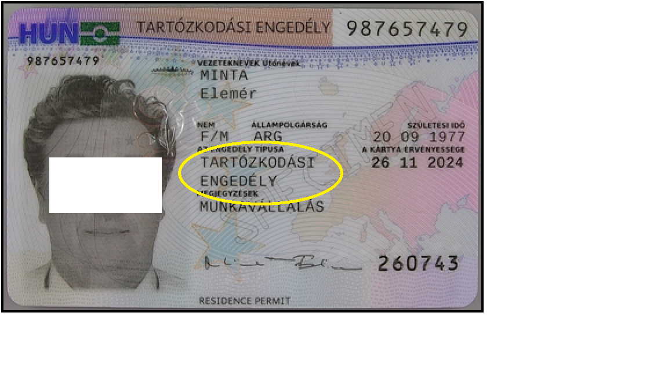
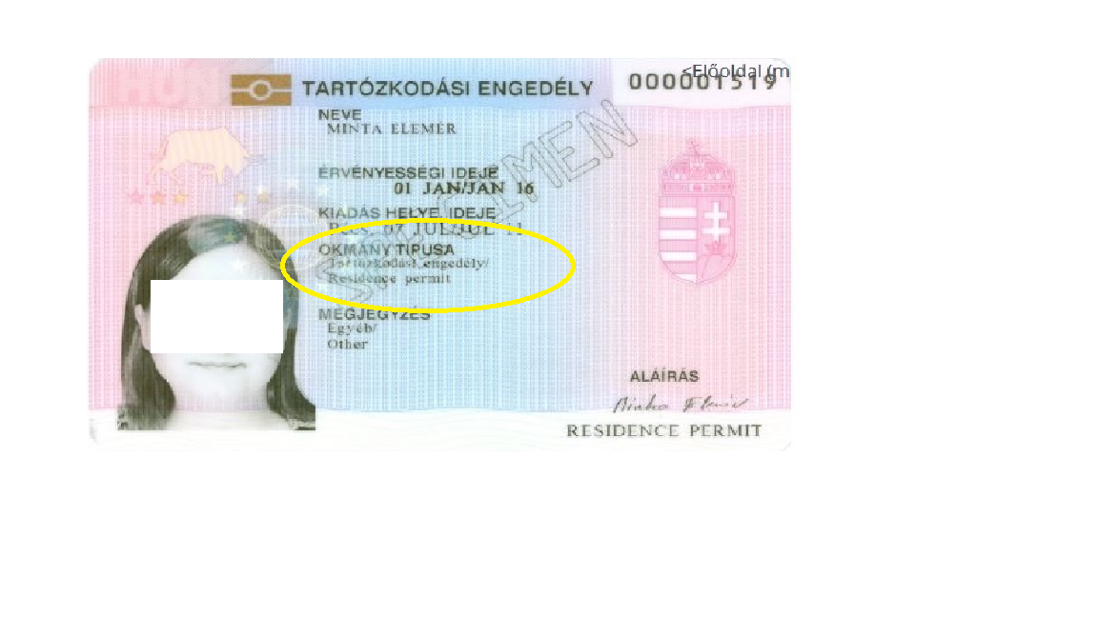
On the vaccination registration interface YOUR NAME MUST BE ENTERED IN EXACTLY THE SAME FORM and ORDER as stated on your residence permit. (see below)

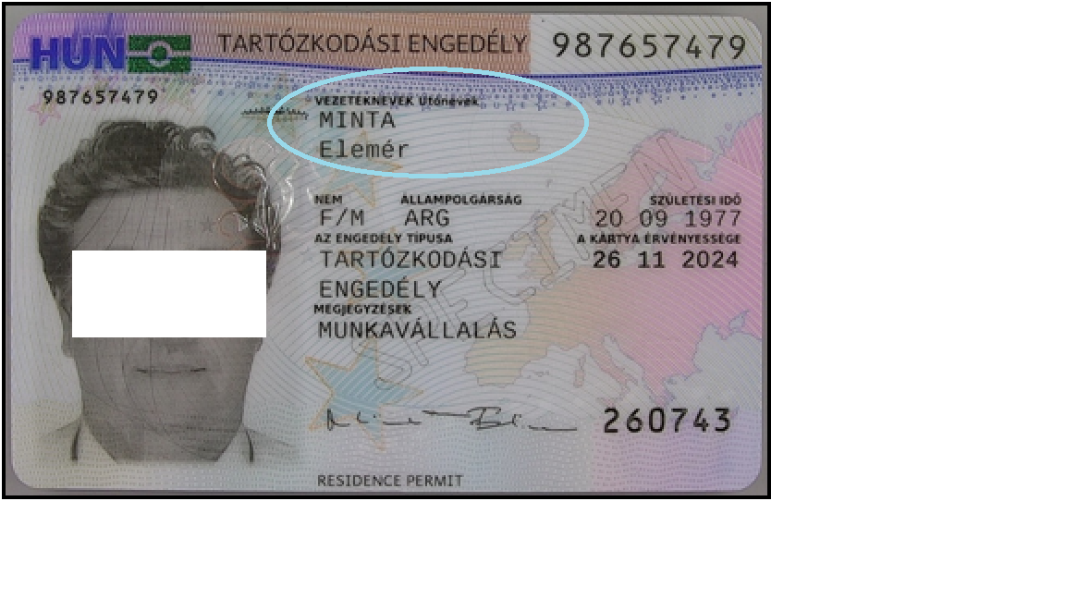

In the vaccination registration interface, the NUMBER OF THE RESIDENCE PERMIT MUST BE ENTERED IN EXACTLY THE SAME FORM as stated on your residence permit. (see below)
The permit number is always a 9-digit number stated on your residence permit.
The residence permit document may only contain numeric and NO alphabetic characters.

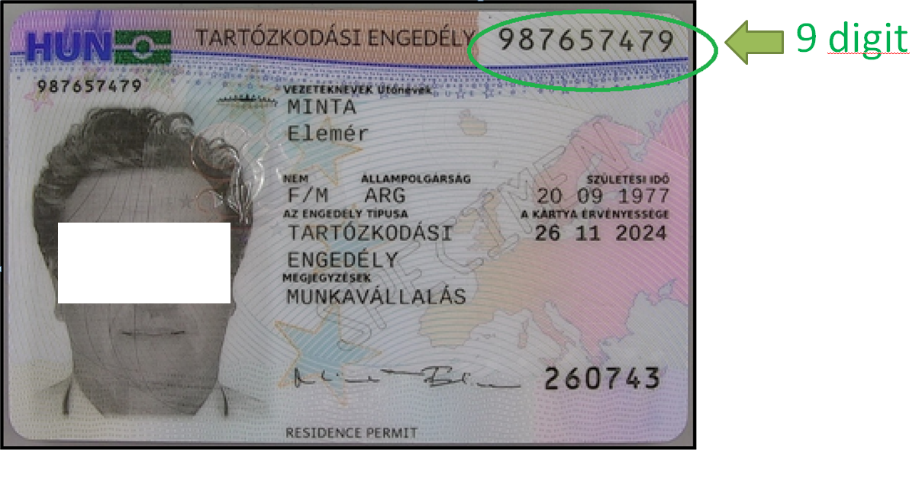
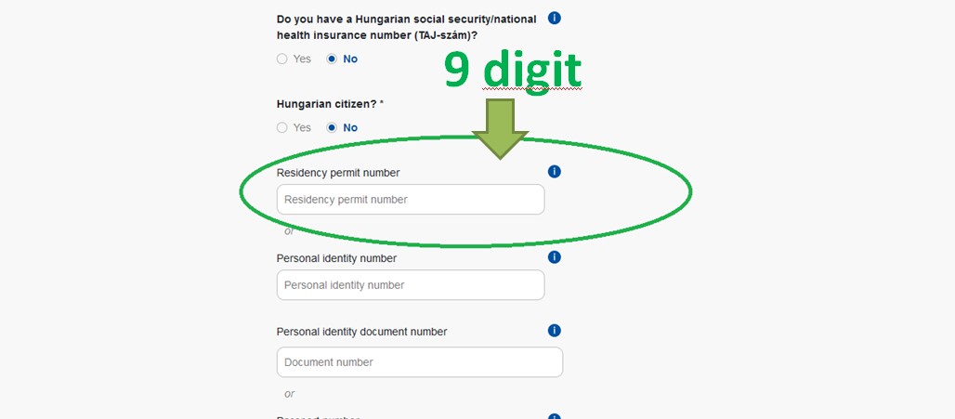

3. A certificate to be issued for EEA citizens - a citizen of a Member State of the European Union other than a Hungarian citizen, and a citizen of a state party to the Agreement on the European Economic Area (citizens of the European Union, Switzerland, Norway, Iceland and Liechtenstein).

Registration certificate

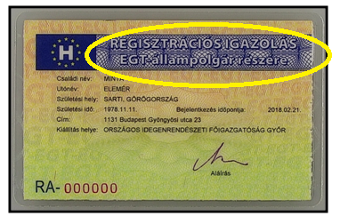

If you hold the above document, you do NOT need to enter your residence document or passport number on the vaccination registration interface but your PERSONAL IDENTIFICATION NUMBER (see below).
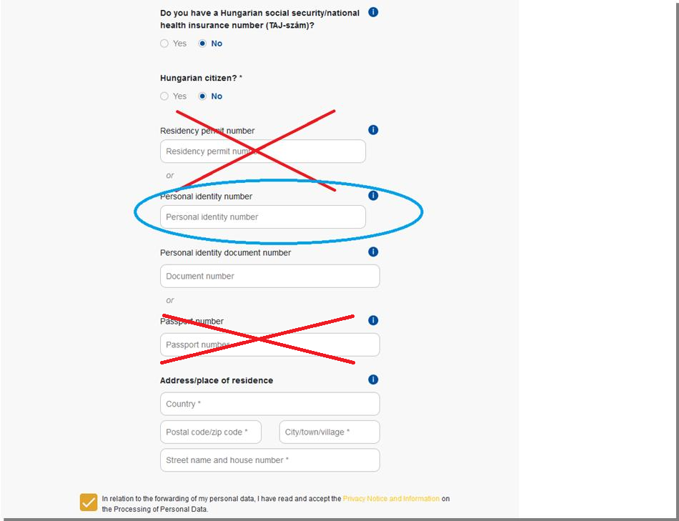

Your Personal Identification Number is to be found on the back of your address card.

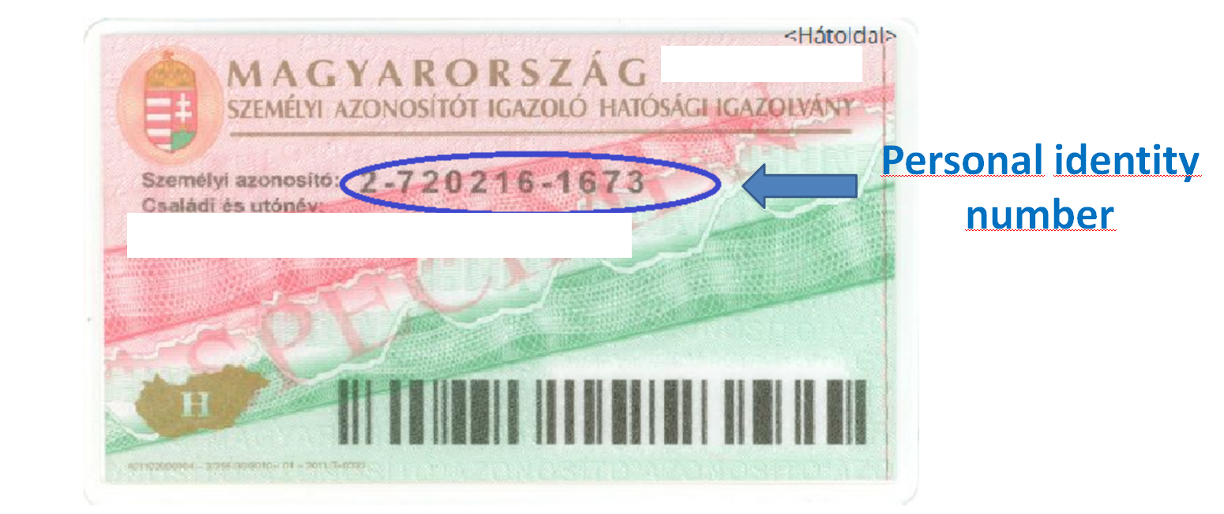

4. Provisional residence permit
In certain cases, third-country nationals will be issued with a provisional residence permit pending the issue of the residence permit.

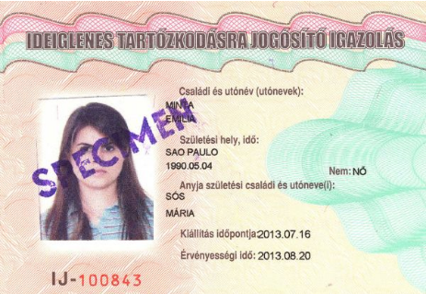
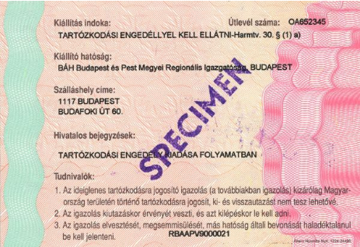

If you hold the above certificate, you are not entitled to register for the vaccine, as this only proves the right of residence in Hungary provisionally, pending the issue of the residence permit referred to in point 2) (for a few days).

When you apply for a residence permit, you must appear in person before the Regional Directorate of the National Directorate-General for Aliens Policing, for the purpose of taking a facial image and a fingerprint in order to issue a residence document containing biometric data, which the third-country national is required to tolerate.
If you only hold the above document, please wait with your registration until your residence permit referred to in point 2) is issued. Following that, please complete your registration as described in point 2).

III. APPLICATION FOR VACCINATION IN HUNGARY
Registration for vaccination - it is possible at the following link, in possession of a valid residence permit issued for at least 90 days, both in Hungarian and English:
https://vakcinainfo.gov.hu/
The following information is to be specified during registration:
a) given name:
b) age,
c) the document identifier of the identity card,
d) passport document identifier,
e) residence permit number,
f) Personal ID Number,
g) address or notification address (address for delivery of the certificate of protection),
h) electronic contact (e-mail and telephone number).

After registration, you can book an appointment at the link below:
- in Hungarian, if holding a social security (TAJ) number: https://www.eeszt.gov.hu/hu/web/guest/covid-oltas-idopontfoglalas
- in English: https://www.eeszt.gov.hu/hu/covid-vaccination-booking
While booking an appointment, the date of the vaccination, the vaccination centre and the vaccine may also be selected (subject to availability at the vaccination centre)

IV APPLICATION FOR CERTIFICATES OF PROTECTION
Certificates of protections:
- Hungarian certificate of protection
- European Union Digital COVID Certificate (DCC)

A) APPLICATION FOR A HUNGARIAN CERTIFICATE OF PROTECTION
Any person is entitled to a certificate of protection who is vaccinated with a COVID-19 vaccine licensed in the European Union and in Hungary and used to vaccinate the population in Hungary in accordance with the relevant legal provisions in Hungary and, as specified below, in the countries also listed in point 1.

1. Who is entitled to a certificate of protection?
- Anybody who received the first vaccination in the territory of Hungary, or any non-Hungarian citizen legally staying in the territory of Hungary for more than 90 days within any 180-day period who received his first vaccination in the following countries:

Member States of the European Union: Austria, Belgium, Bulgaria, Croatia, Cyprus, Czech Republic, Denmark, Estonia, Finland, France, Germany, Greece, Ireland, , Italy, Latvia, Lithuania, Luxembourg, Malta, Netherlands, Poland Portugal, Romania, Spain, Sweden, Slovakia, Slovenia

European Union candidate countries: Albania, North Macedonia, Montenegro, Serbia, Turkey

Organisation for Economic Cooperation and Development (OECD):
Australia, Austria, Belgium, Canada, Chile, Colombia, Czech Republic, Denmark, Estonia, Finland, France, Germany, Greece, Hungary, Iceland, Ireland, Israel, Japan, Latvia, Lithuania, Luxembourg, Mexico, Netherlands, New Zealand, Norway, Italy, Poland , Portugal, South Korea, Spain, Switzerland, Sweden, Slovakia, Slovenia, Turkey, United Kingdom, United States of America

Members of the North Atlantic Treaty Organization (NATO): Albania, Belgium, Bulgaria, Canada, Croatia, Czech Republic, Denmark, Estonia, France, Germany, Greece, Hungary, Iceland, Italy, Latvia, Lithuania, Luxembourg, Montenegro, Netherlands, North Macedonia, Norway, Poland, Portugal, Romania, Spain, Slovakia, Slovenia, Turkey, United Kingdom, United States

Member States of the Cooperation Council of Turkic Speaking States: Republic of Azerbaijan, Republic of Kazakhstan, Kyrgyz Republic, Republic of Turkey, Republic of Uzbekistan

In addition, in the Russian Federation, the People's Republic of China, the United Arab Emirates, the Kingdom of Bahrain and in a country specified in a decree of the Minister of Foreign Affairs in agreement with the Minister of Public Security.

If a non-Hungarian citizen has been vaccinated against the coronavirus in one of the countries listed above, he can apply for a certificate of protection in person at any Government Office or electronically.
Decree 7/2021(IV. 29.) KKM on determining the mutual acceptance of certificates of immunity sets out a list of countries with which a bilateral agreement has been concluded on the mutual acceptance of certifications of protection. Furthermore, the list of contracted countries will be published on the website www.konzuliszolgalat.kormany.hu.
2. How to apply for a certificate of protection - if you have been vaccinated in Hungary?
Foreign nationals without a TAJ number, if registered at www.vakcinainfo.gov.hu website, and were vaccinated in the territory of Hungary, the certificate of protection is issued for them automatically, ex officio.
3. How can foreigners vaccinated abroad and legally residing for more than 90 days within any 180-day period apply for a certificate of protection in Hungary?

As of June 28 2021, any non-Hungarian citizen legally residing in the territory of Hungary for more than 90 days in any 180-day period, vaccinated in any of the countries listed in point 1 may apply to be issued a certificate of protection in person at any Government Office or electronically, free of charge. If applying electronically, the form on the www.magyarorszag.hu website must be completed.

Please note that foreign nationals vaccinated abroad are cannot use the Certificate of Protection Application.

4. What documents are to be attached by a non-Hungarian citizen vaccinated abroad?

A certificate issued by the foreign authority or the healthcare provider performing the vaccination in Hungarian or English, in the absence of which an authentic Hungarian translation of the certificate in another foreign language must be attached to the application, provided that the certificate includes the type of coronavirus vaccine, and the date and place of vaccination.

5. How long does it take to complete a certificate of protection?

After March 1, 2021, after vaccination in Hungary, the certificate of protection will be issued ex officio and mailed within 8 days. As mentioned above, in the case of vaccination in another country, it will be issued within 15 days of the submission of the application.

6. How do I receive the certificate of protection?
In all cases, the certificate of protection will be served by post. The certificate of protection will be served at the notified place of residence, at the notification address provided during the registration/ submission of the application, or in the absence of this, to the address of residence.

7. How long does the validity of the certificate of protection last?
According to the current regulations, the vaccination certification card has no validity period.

B) APPLICATION FOR A EUROPEAN UNION DIGITAL COVID CERTIFICATE (DCC):
As of July 1 2021, it is possible in Hungary to issue an EU Digital Covid Certificate (DCC) referred to in Regulation (EU) No 2021/953 of the European Parliament and of the Council of 14 June 2021 on a framework for the issuance, verification and acceptance of interoperable COVID-19 vaccination, test and recovery certificates (EU Digital COVID Certificate) to facilitate free movement during the COVID-19 pandemic (hereinafter the EU Regulation).
1. To whom can a digital Covid Certificate (DCC) be issued?
A Digital Covid Certificate (DCC) can also be issued to anyone who:
- is vaccinated against coronavirus - Vaccination certificate
2. What data are to be used to issue a Digital Covid Certificate?

The Digital Covid Certificate can be issued on the basis of the data of the person concerned registered in the EESZT (National eHealth Infrastructure).
3. How is it possible to be issued with a Digital Covid Certificate?
In the case of a foreigner with no TAJ number, the issue of a Digital Covid Certificate may be applied for in person at the Government Offices. In this case, the DCC will be sent out in printed form by post.
4. What information is to be specified during a personal application?
The application must include the natural identification data of the person concerned and, if available, his TAJ number. If the person concerned does not have a TAJ number, the application must include the number of the person's official identity card, which is specified by the person concerned to the health care provider during his health care provided for the circumstances on which issuing the Digital Covid Certificate is based according to the EU Regulation.
5. In the absence of a vaccination registered with the EESZT, who can apply for a vaccination certificate?
- Anybody entitled to a certificate of protection with regard to vaccination abroad under Government Decree 60/2021 (II.12.) on certifying immunity to coronavirus.
- Any person holding a certificate of protection issued by a state whose certificate of protection issued by that state is recognised in Hungary, and this fact has been established by the Minister responsible for foreign policy in a decree issued in agreement with the Minister responsible for border policing.
- The vaccination was performed using a vaccine approved in Hungary.
The persons concerned may submit their application for a vaccination certificate only at Government Offices.
The certificate will be issued to holders upon request. In the event of a request, the competent and responsible healthcare provider records the information about vaccinations in the EESZT.
6. What is the content of the application by persons referred to in point 5?
The application must contain the natural identification data of the person concerned, the number of his official identity card and the Hungarian or English language certificate of vaccination issued by the foreign authority or the vaccinating health care provider, in the absence of which an authentic Hungarian translation of the certificate issued in another foreign language, provided that the certificate includes the data specified in paragraph 1 (c) to (j) of the Annex to the EU Regulation, as follows:
(c) disease or agent targeted: COVID-19 (SARS-CoV-2 or one of its variants);
(d) COVID-19 vaccine or prophylaxis;
(e) COVID-19 vaccine product name;
(f) COVID-19 vaccine marketing authorisation holder or manufacturer;
(g) number in a series of doses as well as the overall number of doses in the series;
(h) date of vaccination, indicating the date of the latest dose received;
(i) Member State or third country in which the vaccine was administered;
(j) certificate issuer.

The issuing body issues the EU COVID certificate if there is proof of the administration of the vaccine approved in Hungary and used to vaccinate the population.

The persons concerned may submit their application as of 9 August 2021.

7. The issuance of a DCC for those vaccinated abroad may be applied for as of 9 August 2021:

An application for the issuance of a DCC can be submitted in person at any Government Office. It is necessary to attach the received vaccination certificate in Hungarian or English. Based on that document, the Government Office will contact “the competent and responsible health care provider”. The DCC will be issued after the data is recorded by the healthcare provider, which delivered by post as hard copy to the foreign applicant with no TAJ number.

8. Who can be deemed to be protected due to a coronavirus vaccine?
Those vaccinated at least on one occasion with a vaccine approved in Hungary and used to vaccinate the population, provided the one year has not yet elapsed since the first vaccination. The vaccination certificate is valid for 1 year.
9. Does the type of vaccine affect the issuance of the vaccination certificate?
All vaccinated individuals can receive a vaccination certificate, regardless of which coronavirus vaccine they have received. Member States must accept certificates attesting the administration of a vaccine with an EU marketing authorisation, so the holders of such documents will in any case be exempted from the epidemiological restriction on free movement. Member States may decide to extend the exemption to EU travellers who have received other vaccinations.
10. Covid-19 certificates issued by third countries
If a vaccination certificate has been issued in a third country for a vaccine corresponding to a Covid19 vaccine authorised in the Union and the Member State authorities have received all the necessary information, including reliable evidence of the administration of the vaccine, those authorities may issue the vaccination certificate to the person concerned upon request. Member States are not required to issue a vaccination certificate for any Covid19 vaccine not authorised for use on their territory.
In Hungary, the digital COVID Certificate may be applied for by those who are entitled to a certificate of protection with regard to the vaccination received abroad, in accordance with Government Decree 60/2021 (II. 12.) on certifying immunity to coronavirus, and who hold a certificate of protection issued by such a state that a certificate of protection issued by that state is recognised in Hungary, and this fact has been established by the Minister responsible for foreign policy in a decree issued in agreement with the Minister responsible for border policing.
PLEASE NOTE THAT THE HUNGARIAN CERTIFICATE OF PROTECTION AND THE DCC CAN BE APPLIED FOR AT THE SAME TIME AT THE GOVERNMENT OFFICE. YOU WILL NOT BE ENTITLED TO USE THE APPLICATION, BUT YOU WILL RECEIVE A HARD COPY OF THE DCC AND THE HUNGARIAN CERTIFICATE OF PROTECTION BY POST, AT THE POSTAL ADDRESS SPECIFIED IN THE APPLICATION.

Legislation on vaccination and protection of foreign nationals:
- Section 9/E (2) of Government Decree 479/2020 (XI. 3.) on further protective measures applicable during the period of state of danger
- Section 7/A of Government Decree 60/2021 (II. 12.) on certifying immunity to coronavirus.
- Government Decree 366/2021 (VI. 30.) on certain questions related to the issuance of the EU Digital COVID Certificates during state of danger.

